|  |  |  |
| --- | --- | --- |
|  | Sayan Pandey |  |
|  | 15/IT/21 |  |



Made By

Abstract

To build a student-admin portal which would enable the students to register themselves and update their information, while admin will have the full control over the administration of students’ account.

Student-Admin Portal

Computer Science, NIT Durgapur

**Title**

To build a student-admin portal which would enable the students to register themselves and update their information, while admin will have the full control over the administration of students account.

**Introduction**

A Student-Admin portal system wherein student can request for registration with the portal and administrator can review (accept / reject) his/her request. On acceptance of a request, a student can modify additional details like hobbies,address,guardian's email ID etc., anytime as per his/her wish. Student can upload his favorite image as a profile picture and can modify it anytime.

​ Admin has the right to accept/reject a student's request anytime and can inspect students' profile completely but cannot change any details or see their passwords.

**Technology Stack**

**Markup Language**: HTML, CSS

**Programming Language:** JavaScript/jQuery

**Server-Side language:** PHP

**Database:** MySQL

There is an extensive implementation of AJAX and this site is impervious to **SQL Injections** and **Cross Site Scripting** (XSS)

**Page wise features**

1. **Home Page**
   1. The Home page/landing page is designed so that both the students and admins can login via the same page. Following is the design of the home page.
   2. It is implemented using inline-flex to attach both the login(student and admin) side by side to each other.



1. **Student login Page**
   1. In the student portal we have a bunch of options implemented in the navigation bar. Some of these features are explained in the following points
      1. **Home**: This redirects the student to the home page
      2. **Register**: This is used for new registration of the student
      3. **Login**: This is used for student login
      4. **Profile**: Using this option the student can view their profile
      5. **Logout**: This is used for logging out the student.
   2. **Code:** The following is the PHP code for students’ page

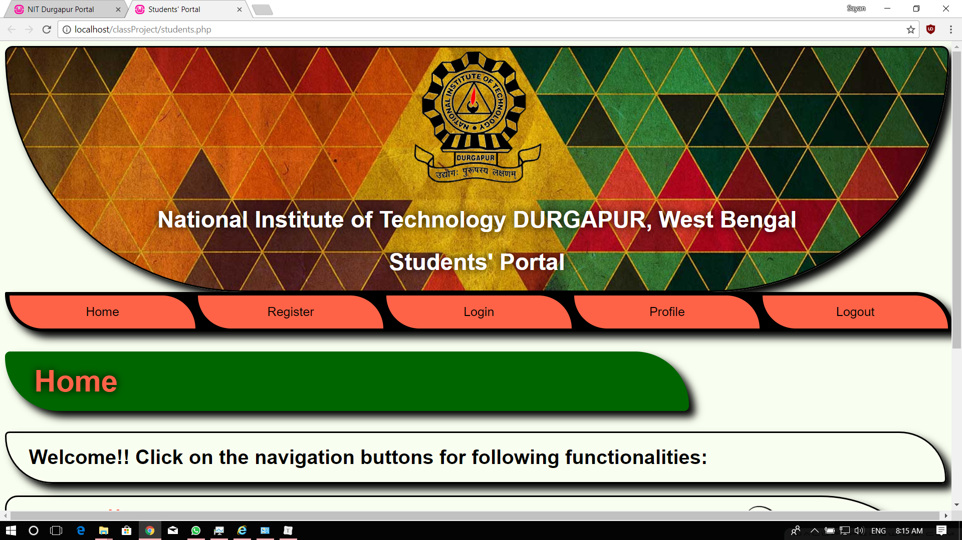

1. **Admin Login Page**
   1. The admin panel has four options
      1. **Home:** To return to home page/landing page.
      2. **Login:** To login as an admin
      3. **Requests:** To view the pending requests of students who registered.
      4. **Logout:** To logout from the account
   2. **Code:** The following is the PHP code for admin login page

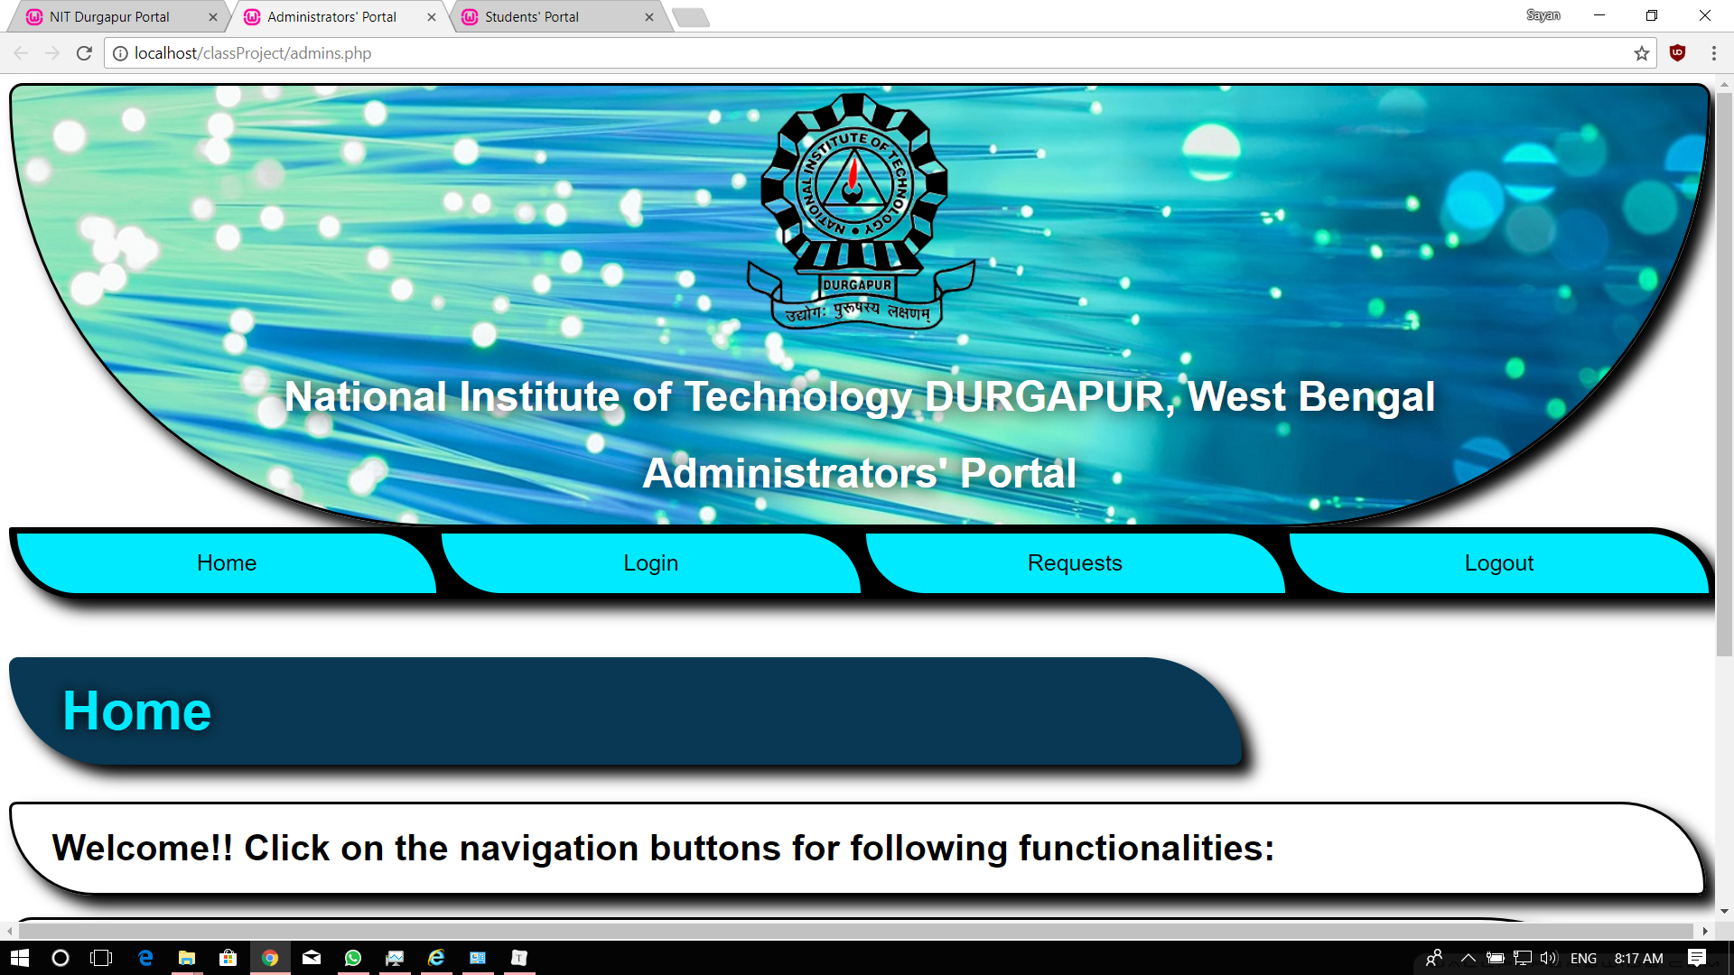

1. **Admin Home Page**
   1. After the admin successfully gets logs in, he is welcomed with a page that consists of all the pending requests that the students have made.
   2. **Features:**
      1. **Accept a request:** The admin can accept the students request to join.
      2. **Reject a request:** The admin can reject the students request to join.
      3. **Inspect profile:** The admin can check the students profile in order to verify him. Upon inspecting the profile, the admin can see all the information provided by the student.
      4. Apart from the above-mentioned features, the admin can also view the list of rejected students, accepted students and new requests by the students.
      5. The admin can anytime reject the accepted request and vice-versa.

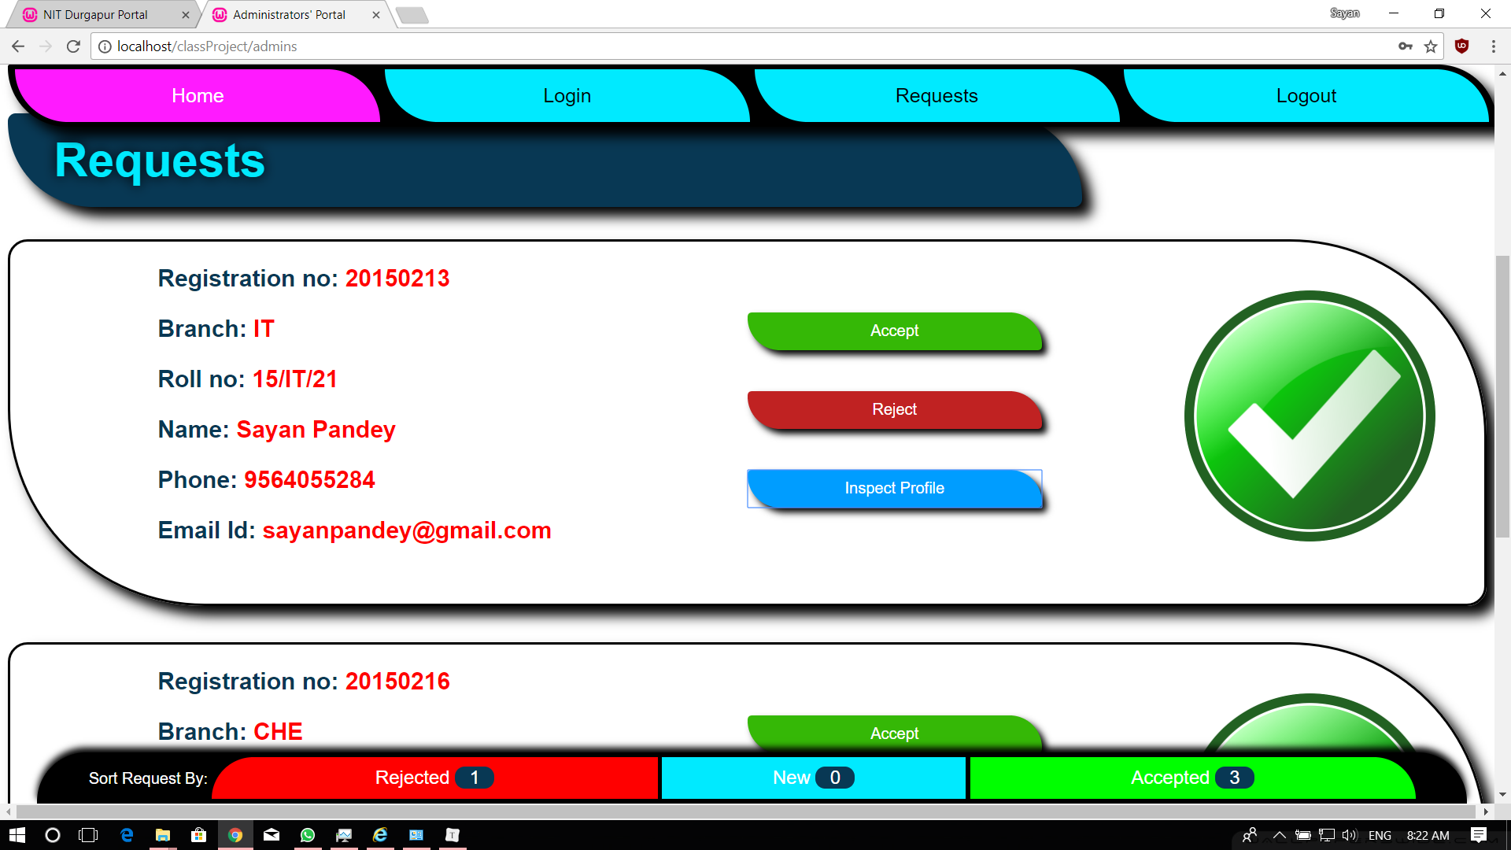

1. **Student Registration page**
   1. In the students’ registration page, the student needs to enter the basic profile information like Department, Branch, Roll No, Name, Phone, Email - ID and password. Once the student successfully fills all the required fields he becomes temporarily registered and the request is sent to the admin for verification.
   2. **Validation:**
      1. The Validation that are performed are the following:
         1. Based on the branch selected by the student, the Roll number field automatically gets filled up.
         2. Password matching

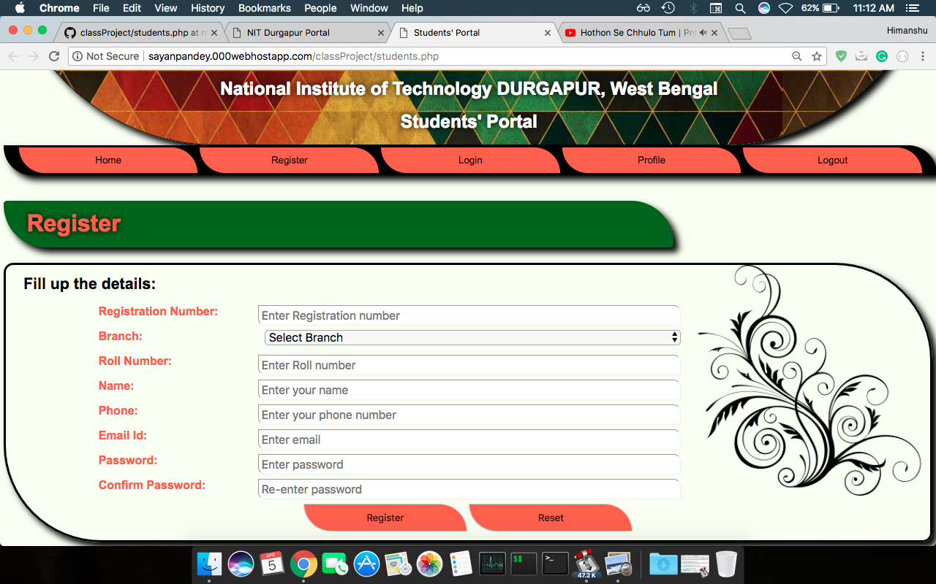

1. **Student Home Page**
   1. In the student home page, the following features are provided.
      1. **Upload Photograph:** The student can upload and submit their profile picture.
      2. **Basic Profile:** The student can view the information they submitted at the time of registration.
      3. **Additional Details:** This section is divided into 3 sections.
         1. **Personal Details:** This section mainly deals with the personal information of the student like Date of Birth, Age, Parents/Guardian Details etc.
         2. **Academic Details:** This section corresponds to the academic details of the student like the 10th marks, 12th marks, Scholastic details and Extra-curricular activities.
         3. **Hobbies Section**: This section corresponds to the Hobbies where the student can select his/her hobbies.
      4. Apart from these basic functionalities, the student can anytime update/modify his/her choices.

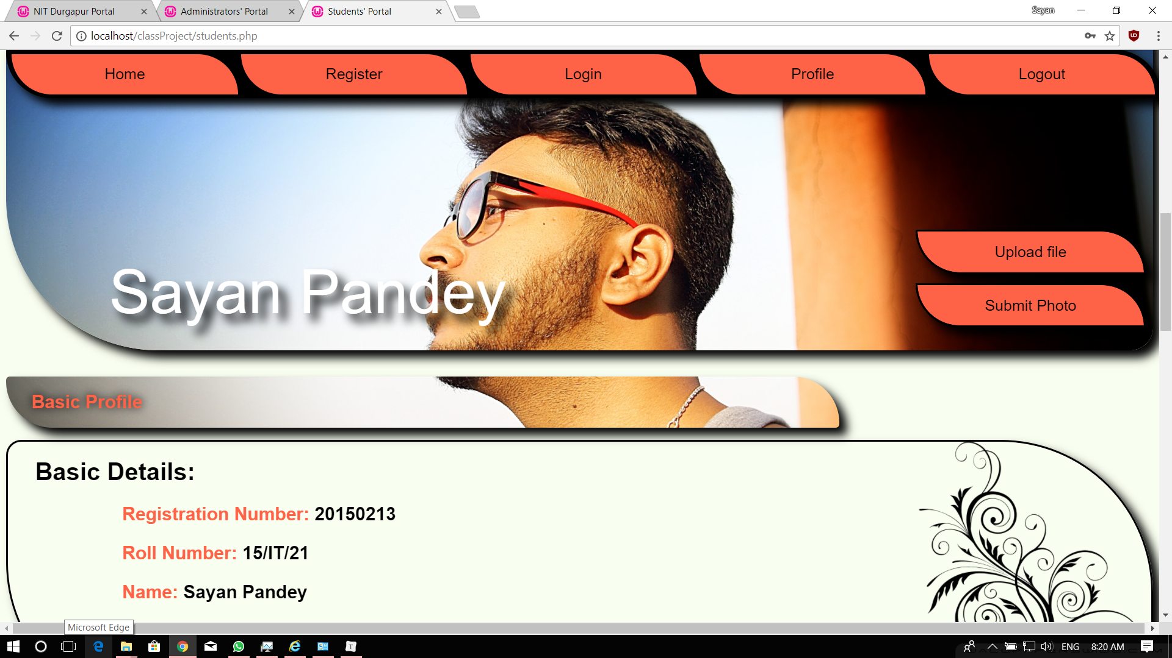

**Details of validation**

Various Data input validation has been performed in order to improve the user experience. Some of these validations are given below:

1. **Student Registration:**
   1. **Roll Number validation**: In the student registration page, when the student enters his department the Roll number gets accordingly arranged. This ensures that the roll number is in consistent with the department.
   2. **Password Validation**: During the password input in the student registration page, we have a password and confirm password that are matched and if not equal, a error message is displayed to the student. This ensures the correct and same password entry in both the password fields.
   3. **Phone Number Validation:** In the student registration page, we also have a phone field column, in which the student is required to fill up his phone number. Now, when the student fills up this column we alert the students, if the phone number is not or less than 10 digits.
   4. **Email Validation:** In the student registration, we also have one more field which asks student to enter his/her email address. This input is also validated for standard email pattern.
   5. **Duplicate Registration number:** If the student provides an registration number as input in the registration input, we alert the student for duplicate entries present in the database.
2. **Student Login**
   1. In the student login page, we have validation that checks whether the inputs i.e. username and password are present in the database.
      1. If the entries are not present in the database: We alert the student that no such entries exist in the database.
      2. If the password is wrong: We alert the student that the password is wrong.
3. **Admin Login:** The admin is required to provide his login credentials like username, password for successful login. If the user doesn’t provide correct credentials, then we alert the student regarding the error that occurred. Some common errors are like ‘Password or username wrong’, ‘Username doesn’t exist’ etc.
4. **Student Home Page:** After the student logs into his account after successful registration, he is given a set of inputs that are also validated. These input fields are explained below:
   1. **Date of Birth**: The D.O.B is by default taken as dd/mm/yy. If the student input doesn’t correspond to this pattern, an alert is raised.
   2. **Age**: The age of the student is automatically set according to the DOB.
   3. **Guardian’s Email Address:** The guardian email address is also validated according to the standard format of email address.

**Session management**

The session is maintained by maintaining a boolean variable that sets a profile to 0 if logged out else 1 if successfully logged in. Thus, there is a proficient session management between the student and admin accounts.

**Some Important Code Snippets**

* **Javascript:**

**Age Calculation**

//age

$("input[name ='DOB']").change(function(){

var dob=new Date($(this).val());

var today= new Date();

var age=today.getFullYear()-dob.getFullYear();

if(today.getMonth() < dob.getMonth() || (today.getMonth()==dob.getMonth() && today.getDate()<dob.getDate()))

age--;

$("input[name ='age']").val(age);

});

**Roll no Installing**

//Roll no insatalling $("#register").find("input[name='regno'],select[name='branch']").blur(function(){

x=$("#register").find("input[name='regno']").val();

var selected = $("select[name='branch'] option:selected").val();

x=x/10000;

if(x>999 && selected!="Select Branch"){

if(Math.floor(x)%100<=9) //Special case for year 2001,2002,2003 etc

$("input[name=rollno]").val("0"+Math.floor(x)%100+"/"+selected+"/");

else

$("input[name=rollno]").val(Math.floor(x)%100+"/"+selected+"/");

}

else

$("input[name=rollno]").val(null);

});

**Registration using Ajax**

//Ajax registration

$("#register").find('form').submit(function(e){

e.preventDefault();

serializedData=$(this).serialize();

var request=$.ajax({

url: "reg.php",

type: "post",

data: serializedData

});

request.done(function (response, textStatus, jqXHR){

$("#message").text(response);

});

request.fail(function (jqXHR, textStatus, errorThrown){

            alert("Unable to Handle request please try again later !!");

        });

});

$("input[name ='DOB']").change();

$("#age").text($("input[name ='age']").val());

});

**Validation of Fields:**

//Validation

function Validate(x){

//Block register button

$("#register").find("button[type=submit]").attr("disabled","disabled");

//Registration Number

if($(x).attr('name')=="regno"){

if(!$(x).val())

$("#regnoError").css({'background-color':'red','color':'white'}).text("Please Insert Registration Number !!").slideDown();

else if($(x).val()<10000000)

$("#regnoError").css({'background-color':'red','color':'white'}).text("Registration Number less than 8 digits").slideDown();

else

$("#regnoError").css({'background-color':'#65FF00','color':'green'}).text("Registration Number Ok");

}

//Roll no

else if($(x).attr('name')=="rollno"){

if(!$(x).val())

$("#rollError").css({'background-color':'red','color':'white'}).text("Please complete above details to get roll no!").slideDown();

else if(!(/^[0-9]{2}\/(CSE|IT|ECE|ME|CE|CHE|EE|MME|BT)\/[0-9]{2,3}$/.test($(x).val())))

$("#rollError").css({'background-color':'red','color':'white'}).text("Insert a Valid Roll no").slideDown();

else

$("#rollError").css({'background-color':'#65FF00','color':'green'}).text("Roll no Ok");

}

//Name

else if($(x).attr('name')=="name"){

if(!$(x).val())

$("#nameError").css({'background-color':'red','color':'white'}).text("Please Insert your NAME !!").slideDown();

else if(!(/^[A-Za-z ]+$/.test($(x).val())))

$("#nameError").css({'background-color':'red','color':'white'}).text("Insert a Valid NAME").slideDown();

else

$("#nameError").css({'background-color':'#65FF00','color':'green'}).text("Name Ok");

}

//Phone Number

else if($(x).attr('name')=="phone"){

if(!$(x).val())

$("#phoneError").css({'background-color':'red','color':'white'}).text("Please Insert your Phone Number !!").slideDown();

else if($(x).val()<=1000000000)

$("#phoneError").css({'background-color':'red','color':'white'}).text("Insert a Valid phone Number").slideDown();

else

$("#phoneError").css({'background-color':'#65FF00','color':'green'}).text("Phone Ok");

}

//email

else if($(x).attr('name')=="email"){

if(!$(x).val())

$("#emailError").css({'background-color':'red','color':'white'}).text("Please Insert your Email !!").slideDown();

else if(!(/^\w+@+[a-zA-Z_]+?\.[a-zA-Z]{2,3}$/.test($(x).val())))

$("#emailError").css({'background-color':'red','color':'white'}).text("Insert a Valid Email").slideDown();

else

$("#emailError").css({'background-color':'#65FF00','color':'green'}).text("Email Ok");

}

};

**Image Upload:**

//Image Upload

$('#submit_form').on('submit', function(e){

e.preventDefault();

alert("Wait while image is being uploaded");

$.ajax({

url:"upload.php",

method:"POST",

data:new FormData(this),

cache:false,

contentType:false,

processData:false,

success:function(received)

{

$("#message2").html(received);

$('.banner,.title2,.profile_back').fadeTo('slow', 0, function(){

$(this).css({'background-image':'url(img/std_img/'+regno+'.jpg'+"?random="+ new Date().getTime()+'),url(img/banner.jpg)',

'background-size':'cover',

'background-position-x':'0px',

'background-position':'center',

'background-attachment':'fixed'

});

}).fadeTo('slow', 1);

}

});

});

**Admins’s Request Review using AJAX:**

function reject(x){

var y = $(x).parent();

var z=$(y).find('a.regno').text();

$.post("response.php",{

regno : z,

response:"-1"

},

function(){

y = y.find('img').slideUp(function(){

$(this).attr("src","img/reject.png");

}).slideDown();

})

}

function accept(x){

var y = $(x).parent();

var z=$(y).find('a.regno').text();

$.post("response.php",{

regno : z,

response:"1"

},

function(){

y = y.find('img').slideUp(function(){

$(this).attr("src","img/accept.png");

}).slideDown();

})

}

* **PHP:**

**Connecting to Database:**

<?php

$server="localhost";

$username="root";

$password="";

$database="classProject";

$conn=new mysqli($server,$username,$password,$database);

if($conn->connect_error)

die('Fatal Connection error!!');

?>

**Lodging Registration Requst:**

<?php

session_start();

$regno=isset($_POST['regno'])?htmlspecialchars($_POST['regno']):0;

$branch=isset($_POST['branch'])?htmlspecialchars($_POST['branch']):0;

$rollno=isset($_POST['rollno'])?htmlspecialchars( $_POST['rollno']):0;

$name=isset($_POST['name'])?htmlspecialchars($_POST['name']):0;

$phone=isset($_POST['phone'])?htmlspecialchars($_POST['phone']):0;

$email=isset($_POST['email'])?htmlspecialchars($_POST['email']):0;

$pass=isset($_POST['password'])?htmlspecialchars($_POST['password']):0;

$request=0;

require 'connection.php';

if($stmt=$conn->prepare(' insert into students (regno,branch,rollno,name,phone,email,pass,request) values (?,?,?,?,?,?,?,?)')){

        $stmt->bind_param("isssissi",$regno,$branch,$rollno,$name,$phone,$email,$pass,$request);

if(!($stmt->execute())){

echo "Execution failed:" . $stmt->error;

die();

}

else{

echo "Successfully lodged Registration Request; Use Login form from next time";

die();

}

    }

?>

**Login for Admins and Students:**

<?php

session_start();

$user=isset($_POST['user'])?htmlspecialchars($_POST['user']):NULL;

$regno=isset($_POST['regno'])?htmlspecialchars($_POST['regno']):NULL;

$pass=isset($_POST['password'])?htmlspecialchars($_POST['password']):NULL;

$logger=isset($_POST['logger'])?htmlspecialchars($_POST['logger']):NULL;

//Code for redirect and LOGOUT as well

if($pass==NULL || $logger==NULL){

session_unset();

session_destroy();

header("Location:/classProject",true,303);

}

require 'connection.php';

//Login for admins

if($logger=='admins'){

$sql="select * from ".$logger." where user=? and pass=?";

if($stmt=$conn->prepare($sql)){

$stmt->bind_param("ss",$user,$pass);

if(!($stmt->execute())){

$_SESSION['alogin']="Execute failed:" . $stmt->error;

header("Location:/classProject/admins.php",true,303);

}

else{

$result=$stmt->get_result();

if($result->num_rows)

$_SESSION['alogin']="You are logged in,Check Requests";

else

$_SESSION['alogin']="Credentials not matching !!";

header("Location:/classProject/admins",true,303);

}

}

}

//Login for students

else if($logger=='students'){

$sql="select request from ".$logger." where regno=? and pass=?";

if($stmt=$conn->prepare($sql)){

$stmt->bind_param("ss",$regno,$pass);

if(!($stmt->execute())){

$_SESSION['login']="Execute failed:" . $stmt->error;

header("Location:/classProject/students.php",true,303);

}

else{

$result=$stmt->get_result();

if($result->num_rows){

while($row=$result->fetch_assoc())

switch($row['request']){

case 0:

$_SESSION['login']="Registration request is being validated; make sure to try again later.";

break;

case 1:

$_SESSION['login']="You are logged in,Check Profile";

$_SESSION['regno']=$regno;

break;

case -1:

$_SESSION['login']="Registration has been rejected!!! CONTACT ADMIN.";

break;

}

}

else

$_SESSION['login']="Credentials not matching !!";

header("Location:/classProject/students.php",true,303);

}

}

}

?>

**Challenges faced**

Some of the challenges that we faced during the

1.The MySQL database connection using PHP

2. CSS Animation

3. Responsiveness of site

**Unique features**

The site is impervious to SQL injections and made using the principles of OWSAP security principles.

The site uses AJAX which can lively manipulate data in database.

**Conculsion**

The is successfully built with great efforts and handwork site is hosted and it is live at:

**http://sayanpandey.000webhostapp.com/classProject**

**References**

We created the site by referring to:

* **W3Schools.com**
* **Stackoverflow.com**
* **Codepen.com**